MISHIKA

SUPER SPECIALITY HOSPITAL

(A Unit of Mishika’s Critical Care Unit & Hospital LLP)

**PROJECT REPORT**

**Date: 17/07/2021**

**Index**

|  |  |
| --- | --- |
| **Particulars** | **Page no.** |
| objective |  |
| Need of multispeciality hospital |  |
| Beneficiary covered area under project |  |
| Facilities provided under mishika superspeciality hospital |  |
| Project requirement-land |  |
| Project requirement -building |  |
| What is planned |  |
| Bed distribution |  |
| Time frame |  |
| Financial projections |  |
|  |  |
|  |  |
|  |  |

**Objectives**

Healthcare facilities have a very important role in improving quality of life of people. With a greater health awareness and consciousness, there is a rising demand for health care facilities and services.

Considering this rising demand, the proposal of superspeciality hospital has following objectives

1. To start , established , maintain ,operate , run and manage “*state of art superspeciality hospital*” for the reception and treatment of persons suffering from different types of illness, ambulance services, blood bank ,diagnostic center and pharmacy
2. To install best available technologies of national and international standard for attainment of afore said objective.
3. Promote the highest level of rehabilitation and independence through restorative nursing care using a team approach and collaborating with therapy disciplines as appropriate.
4. to do all acts , deeds or things as a necessary or expedient for advancement or attainment of a foresaid objects.

**About Mishika Super Speciality Hospital**

Mishika Super Specialty hospital is a 50 bedded Super Specialty hospital at 1/1 Krishna Nagar G.T road Kanpur, near Jugal cinema hall Kanpur, with a state of art intensive care unit , modern labor room, high end modular o.t, and experienced/professional team of doctors , nurses, paramedical staff and administration department. Team is leading from the front by young and dynamic anesthetist and Intensivists, Dr Surendra Patel. He did MBBS from M.L.B medical college Jhansi, (2009) md Anesthesia from S.N Medical College Agra UP ( 2012) and FNB (critical care medicine ) from R. N Tagore International Institute of Cardiac Sciences in 2015. He also enrolled for fellowship program on ECMO under Dr. Pranay Ojha Ridhi Vinayak hospital Mumbai.

He initially started with Mishika Critical Care Unit in the year 2020 at Daheli Sujanpur, Koyla Nagar Kanpur, as a dedicated critical care center with his wife Dr. Pravina Patel (Dermatologist).

Mishika superspeciality is a full-fledged hospital with the services of 24 hours emergency and trauma, pathology, radiology, pharmacy and ambulance services (ACLS and BLS)

*MISHIKA SUPERSPECIALITY HOSPITAL* has a very good team of leading and reputed doctors of the area with a dedication towards their profession, mankind and humanity.

The vision of the hospital is each patient has taken care with the best possible, affordable cost of treatment, and personalized care plan. The tag line of the hospital is ‘***CARE WITH COMPASSION’*.**

**Directors Message:-**

*Dr Pravina Patel*, I am glad to introduce our new venture Mishika Superspeciality Hospital.

Mishika Superspeciality Hospital is established with an aim to deliver cost effective quality healthcare services to the people living in Kanpur, our aim is to provide specialized and tertiary level of healthcare and boast of a highly qualified and dedicated team of consultant doctors and nurses and paramedic staff.

We are committed to achieve patient satisfaction by providing our services at reasonable cost on humanitarian and compassionate grounds; we look forward to your feedback to improve our services and to provide best health care services to the society

**NEED FOR SUPERSPECIALITY HOSPITAL**

1. Superspeciality Hospital is a single point solution for patients that offers diagnosis treatment and hospitality facilities across various clinical specialties in Kanpur
2. Superspeciality Hospital provide standardized , specialize and synchronize diagnosis treatment care and hospitality facilities under one roof
3. Superspeciality Hospital is needed because number of patient with various diseases is increasing because of rising population.
4. There are insufficient number of multi and super Specialty hospital (diagnosis treatment and facilities in south Kanpur and adjoining areas.
5. Increase in disease like diabetes, hypertension and cancer etc. demands for better health care services under one roof.

**We are coming with team of dedicated and experienced professional doctors to provide excellent services.**

1. **Anesthesiology & Critical Care**

* **Dr.Surendra Patel**
* **Dr.Nitin Gupta**

1. **Oncology and oncosurgery**

* **Dr.Arun kumar dwivedi**

1. **Laparoscopic & General Surgeon**

* **Dr.Mayank Porwal**
* **Dr.kautav gupta**

1. **Pulmonary (Respiratory Medicine)**

* **Dr.Anurag Shukla**
* **Dr.M.J. Gupta**

1. **Obstetrics & Gynaecology**

* **Dr.Pratima Katiyar**
* **Dr.Kaustubh Srivastav**

1. **Dermatology , cosmetic surgery and laser**

* **Dr.Pravina Patel**

1. **Urology and urosurgery**

* **Dr.Vineet Kumar**

1. **Maxillofacial & Dentistry**

* **Dr.Rahul Verma**

1. **Neurology**

* **Dr.Ankur sachan**

1. **Neurosurgeon**

* **Dr.Ashish Sharma**
* **Dr.S G Verma**

1. **Nephrology**

* **Dr.Yuvraj Gulati**

1. **Internal medicine**

* **Dr.Ashish Dwivedi**
* **Dr.Padeep Kumar Katiyar**

1. **Paediatrics-**

* **Dr.Vinay Bajpai**
* **Dr.Shashank Mishra**

1. **Cardiology (Non In-Vasive)**

* **Dr.Amit Kumar**

1. **ENT**

* **Dr. N C Verma**

**We are serving these services and specialties.**

* **Anesthesiology & Critical Care Unit**

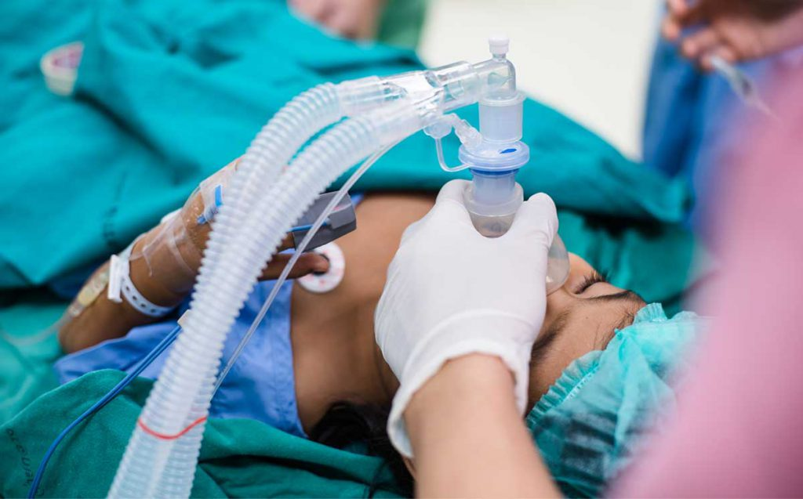

Anesthesia and critical care department is heading by *Dr.suredra Patel (HOD), MBBS, MD, FNB*, and *Dr.Nitin Gupta MBBS, MD. Anesthesia* and critical care unit is a specialty that involves the management of patience with a life threatening, frequently complex medical and surgical illness. These patients may have dysfunction or failure of one or more organ systems, including the cardiac, pulmonary, neurology, liver, kidney or gastrointestinal systems.

Procedures used to help support and identify the cause of the critical illness including *endotracheal intubation I, central venous catheterization, arterial catheterization chest tube* *and tracheostomy*.

* **Pediatric – NICU and PICU**

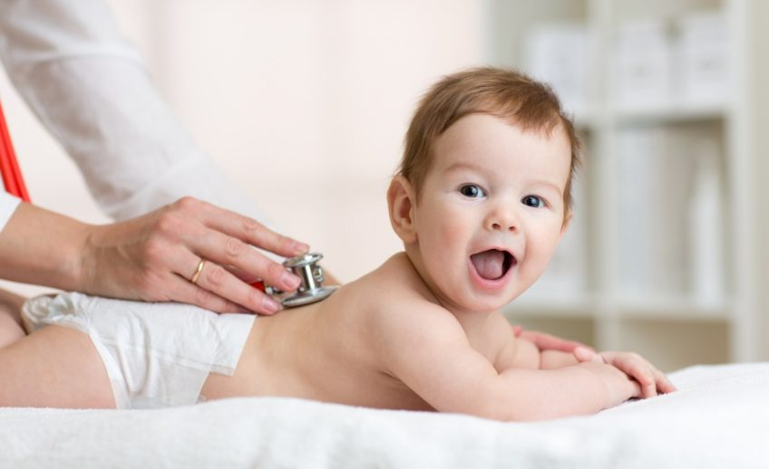

Pediatric team is leading by Dr.Vinay Bajpai and Dr.Shashank Mishra, the department of neonatology and pediatrics offers a complete range of health care services to new born and children that comprises of every day illness to serious childhood diseases.

Immunization facilities for all those disease that can be prevented by vaccination.

5 bedded pediatric intensive care unit with mechanical ventilators and all sophisticated monitoring gadgets needed for critically ill children.

* **Internal Medicine**

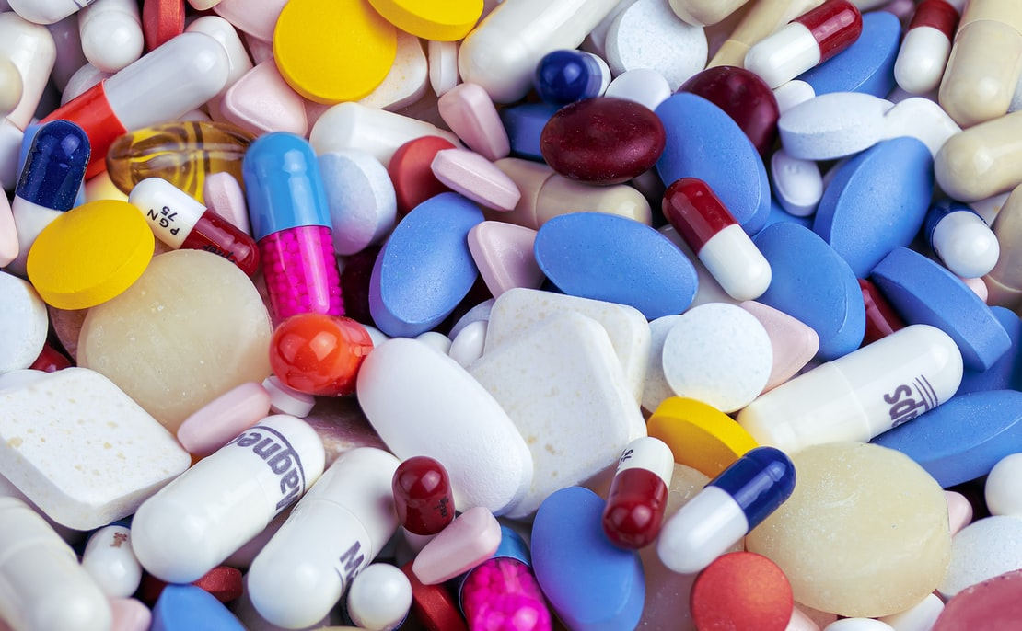

Internal medicine team is headed by Dr. Ashish Dwivedi Internal medicine Department has to support and backup of all superspeciality in the hospital providing end to end services varying from diagnosis, prevention, treatment, wellness, preventive health packages, Rehabilitation services and management of various medical conditions.

We follow a comprehensive, coordinated and holistic approach to treat patient for a wide spectrum of routine and complicated diseases ranging from life style disease obesity, diabetes, thyroid disorder, hypertension, respiratory infections, etc.

* **Obstetrics & Gynecology**

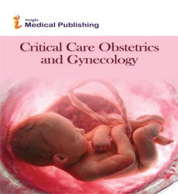

Obstetrics and gynecology department is a fully fledged “ Women’s Health Unit” That caters to the health care needs of women’s of all aged starting from there adolescence , reproductive years , menopause and beyond.

We offer the most advance gynecologic and obstetric care to meet the individual needs of patients that include routine to high risk pregnancies and deliveries, uterine fibroids, urinary incontinence, abnormal bleeding, chronic pelvic pain, gynecologic cancers at menopause.

* **Orthopedics & Trauma Care**

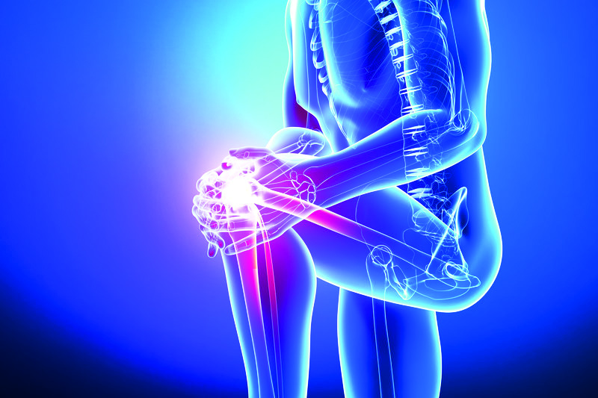

Our orthopedic department can make a real difference in the life’s of people suffering joint and bone pain our institute offers consultations , diagnosis , and treatment of any injury of diseases of bones and joints that may include sports related injuries of knees , hip , shoulders , ankle , and or other joints , fractures , trauma , spinal injury , joint infections, replacements surgeries, spine tuberculosis , spine cancer and tumor etc.

* **Laparoscopy & Minimal Access Surgery**

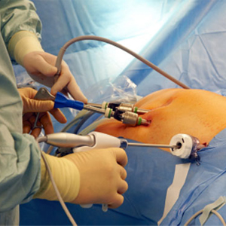

Minimal invasive surgery has revolutionized the way surgery is perform it is also known as key whole surgery or laparoscopic surgery it refers to the use of technics that permit access to internal organs leaving a small scar as compare to open surgeries where a large incision is made

We treat Ailments ranging from a hernia, appendicitis, gall bladder stones, piles, fistula, abscesses cists, gastroesophagal reflux, benign and malignant condition of the liver, small bowel and large bowel.

* **ENT**

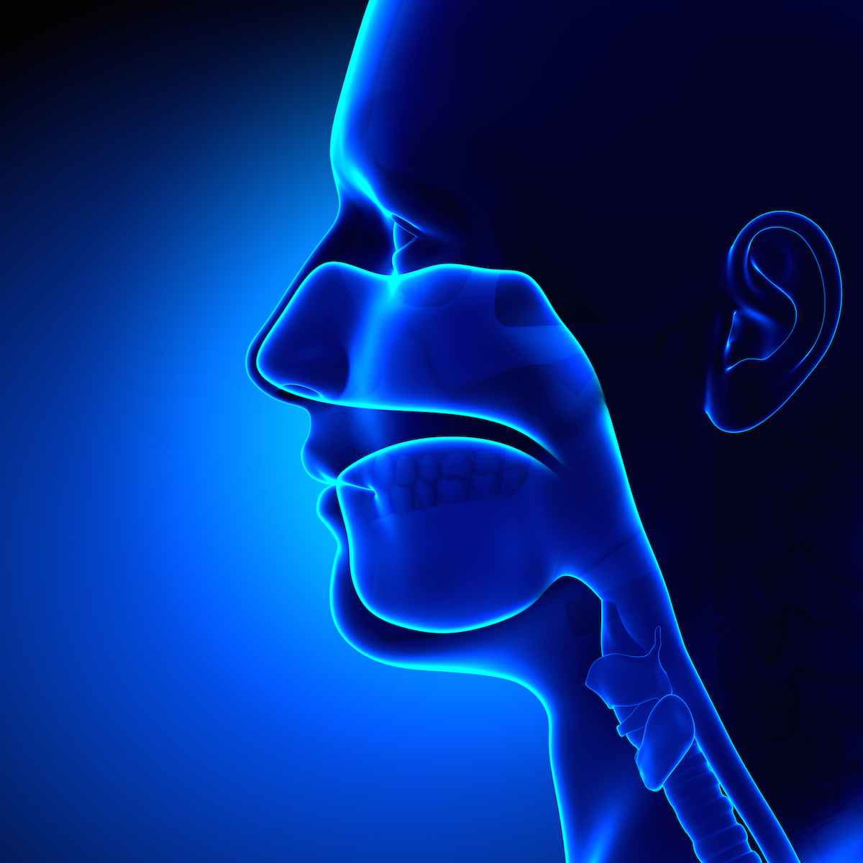

ENT department is headed by a proficient senior consultant Dr. N C Verma , He along with his team delivers high Quality medical services for all disorders related to Ear , Nose and Throat .

Our Medical specialist offer compassionate patient care and treatment for a variety of conditions that include tonsils , thyroid and parathyroid diseases, sinus , snoring problem , nasal trauma , hearing loss and balance problem , voice and swallowing disorders , head and neck cancer.

* **Neurology**

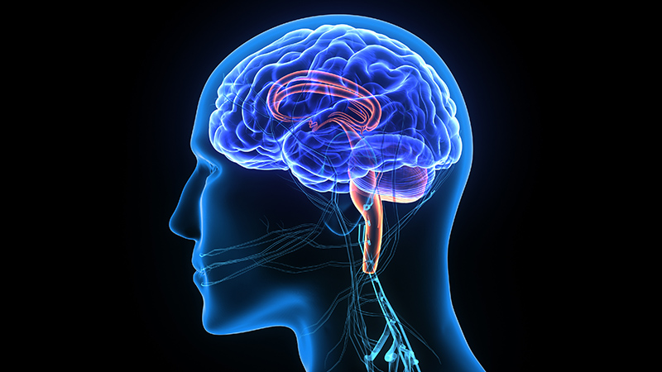

To evaluate and treat a wide spectrum of neurological disorder that includes stroke, epilepsy, headache, bell’s palsy , traumatic brain injury , multiple sclerosis, moment disorder , dementia , cerebral palsy , spasticity , cerebral aneurysms , brain and spinal vascular deformities , sleep disorder and mental / behavior problems

We offer advanced diagnostics, interventions, and rehabilitation services to patients through an integrated health care systems in a cost effective manner.

* **Urology**

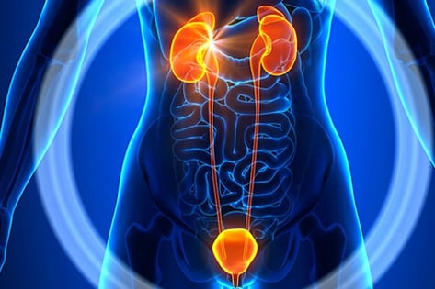

Urological disorders that involve the male and female urinary tract and male reproductive organs can have a significant impact on your health as well as the quality of life.

We deliver excellent medical as well as surgical care for all urological problems including benign and malignant involving kidneys, bladder and prostate, kidney stones, urinary tract infection, prostate enlargement, erectile dysfunction, urinary incontinence, sexually transmitted disease and injury to urologic organs.

* **Nephrology & Dialysis Unit**

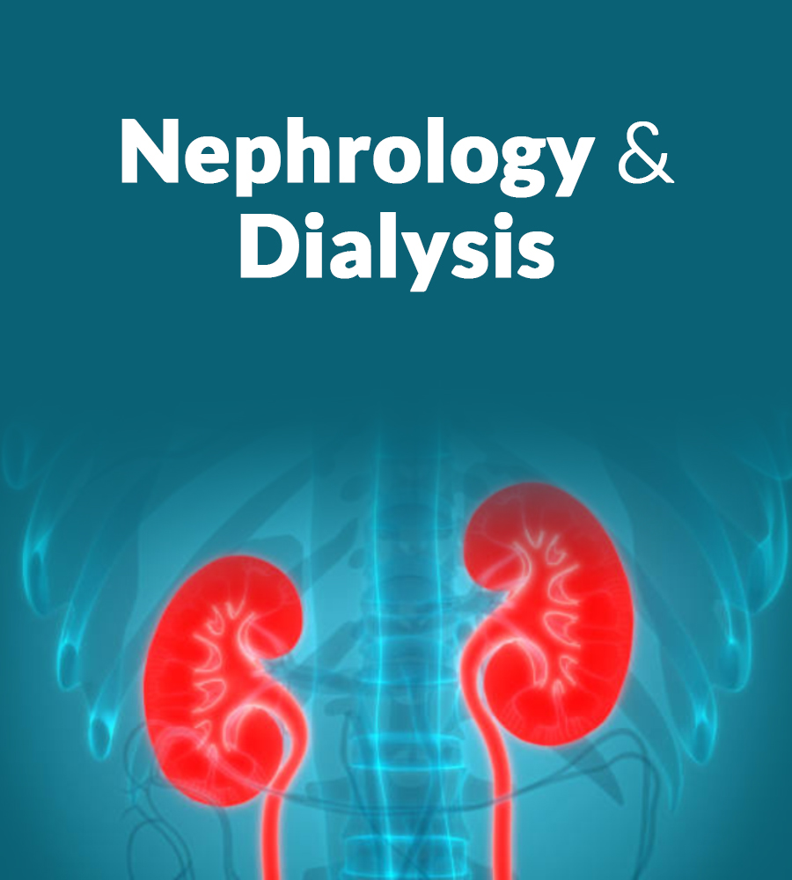

Nephrology department manages both acute chronic renal failure with peritoneal dialysis and hemodialysis with ultra-filtration

Hemodialysis department has a most modern state of the art hemodialysis unit, equipped with three hemodialysis machine. The unit runs three shifts in a day with a facility of emergency of dialysis around the clock.

* **Neurosurgery**

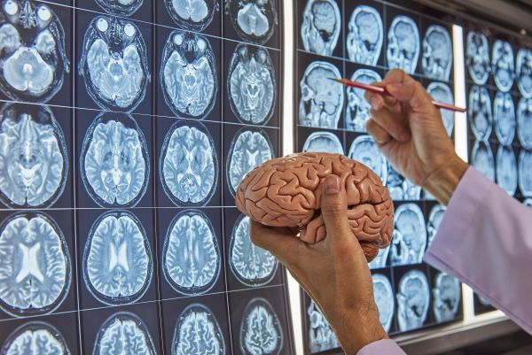

Neurosurgery department will be taking care by our professional doctors Dr.S G Verma and Dr.Ashish Sharma. Neurosurgery department caters to the patients requiring surgical approach for brain, spine and nervous system disorders. We offer Patient centric careful treatment for a wide spectrum of complex and extremely unusual neurological surgical problems that include tumors of brain and spin, brain hemorrhage, severe injuries cost to head, spine and nerves, disc prolapse, spinal dislocation, spine congenital malformations, Parkinson’s disease, and many other related disorders. Neuro-critical care ICU under care of anesthetist Dr.Surendra Patel.

* **Respiratory Medicine**

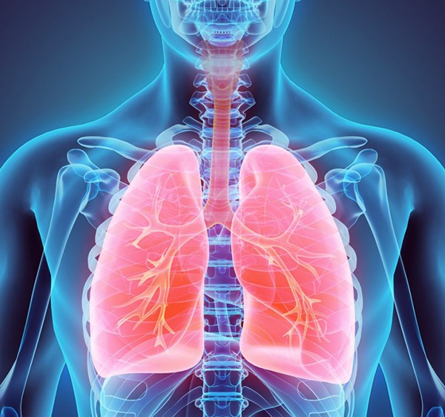

Our Highly competent team of respiratory medicine doctors provides world class services along with coordinated care for patients with severe health problems associated with their lungs and ability to breath that include asthma , pneumonia , bronchitis , lung cancer , interstitial lung disease ,pulmonary hypertension, sleep disorder , acute and chronic respiratory failure

We have an extremely talented and skilled respiratory and intensivists team who handles emergency situation like asthma attack with great care precision.

We also provide mechanical ventilation and other respiratory support measures for critically ill patients in the intensive care unit.

* **Gastroenterology**

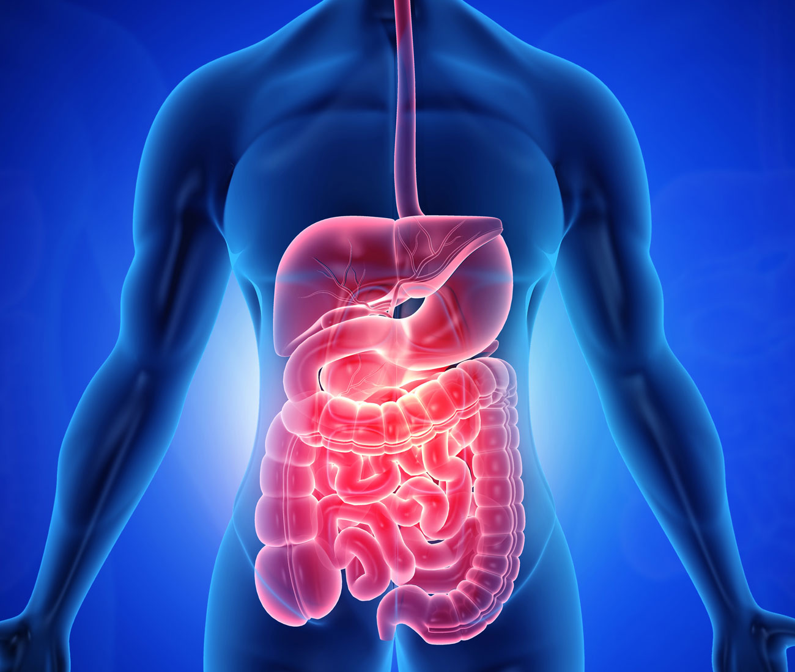

Gastroenterology department offers uniquely integrated high quality care for a wide span of problems ranging from simple ones like indigestion, heart burn , constipation , difficulty in swallowing , vomiting to more complex problems like blood in vomit , bleeding from rectum, jaundice , ascites , liver failure , fatty liver , liver cirrhosis, stones in bile duct , cancer of esophagus, and pancreases.

Our latest state of the art endoscopic equipment used in the department gives detailed test results that are apt for better treatment outcomes.

* **Oncology(medical & Surgical)**

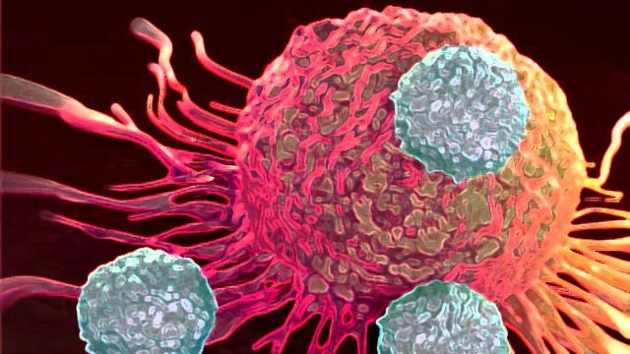

Department of oncology is dedicated to offer unparalleled and compensate care to patient with care and disorders of blood, soft tissue or solid organs.

Our extremely talented oncologist Dr. A K Dwivedi has the expertise and experience to diagnose, treat and manage all types of cancer whether common, complex or rare using a variety of advance treatment method.

We specialized in prostate cancer, lung cancer, head and neck cancer, breast cancer, gastro intestinal, kidney cancer, gynecology cancer and bone/soft tissue sarcomas.

* **Radiology**

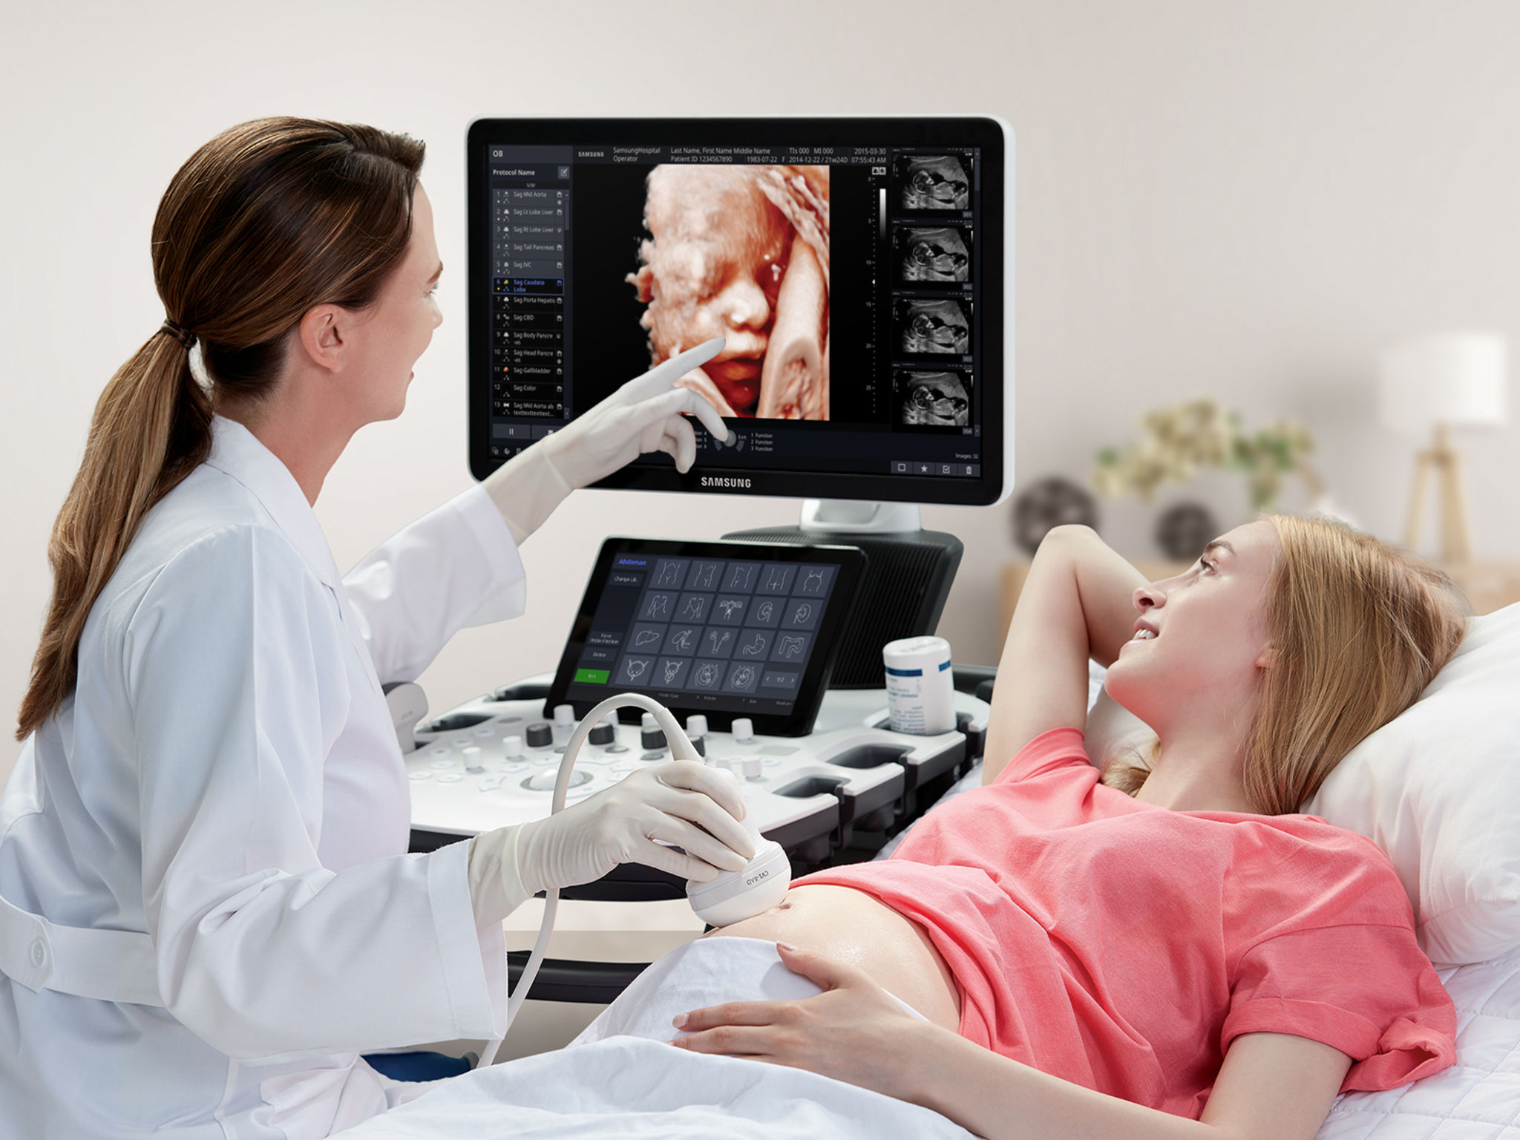

Radiology department provides round the clock clinical services with help of competent, courteous and dedicated staff. The department is well equipped with world class equipment which is loaded with latest technologies and softwares.

Our team of senior radiologist and experienced technicians helps in providing excellent diagnostics images for accurate interpretation and timely reports our all machines are installed under a single roof and are following AERB & PC-PNDT Guidelines.

* **Dermatology & cosmetic surgery**

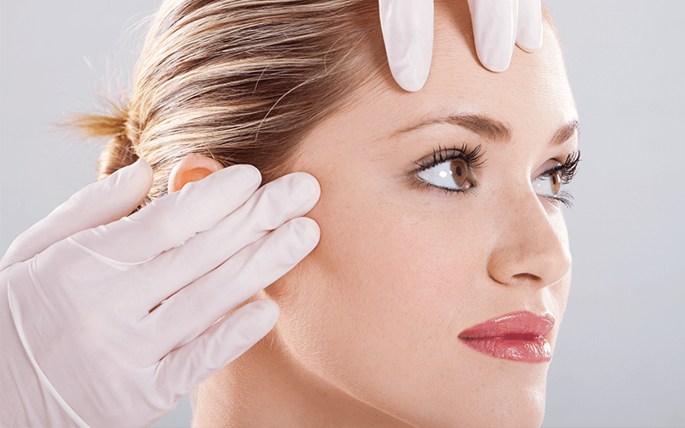

Our dermatology department helps you in maintain good health of your skin so that it can retain its radiance and beauty we are delivering innovative and exceptional dermatology health services for your clinical and cosmetic problems of skin , hair and nails that includes acne , psoriasis , skin allergies , eczema, warts , hair loss and more complex problems like vitiligo and genetic diseases.

Our dermatology department is leading by Dr. Pravina patel MBBS, DVD who successfully diagnoses, treat and manage both common and rare skin, hair and nail conditions.

* **Cardiology (Non-invasive)**

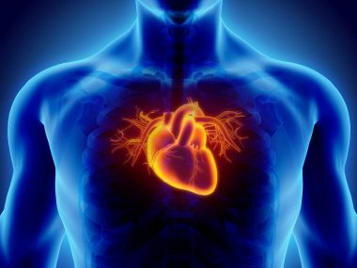

Department of cardiology provides advanced and comprehensive care to patients with routine heart problems to the most complex and rare ones the institute offers high diagnostics and therapeutic capabilities to accurately detect the medical condition of the patient, we can provide them with best suited therapy at the right time.

We treat medical conditions like chest pain, shortness of breath, heaviness and burning sensation in chest, palpitations, nausea, weakness, fatigue, sweating and pain in shoulders or arms.

* **Pathology**

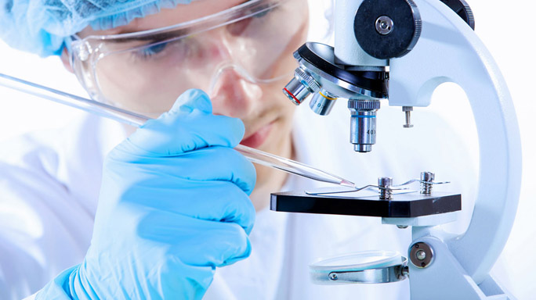

Pathology department provides with the finest equipment for comprehensive diagnostic support to their clinical counter parts and a patient centric approach.

At mishika superspeciality we are offering services of clinical chemistry and immunology, microbiology, serology, molecular biology, histo pathology, cytology and home collation facilities.

* **Physiotherapy & Rehabilitation Centre**

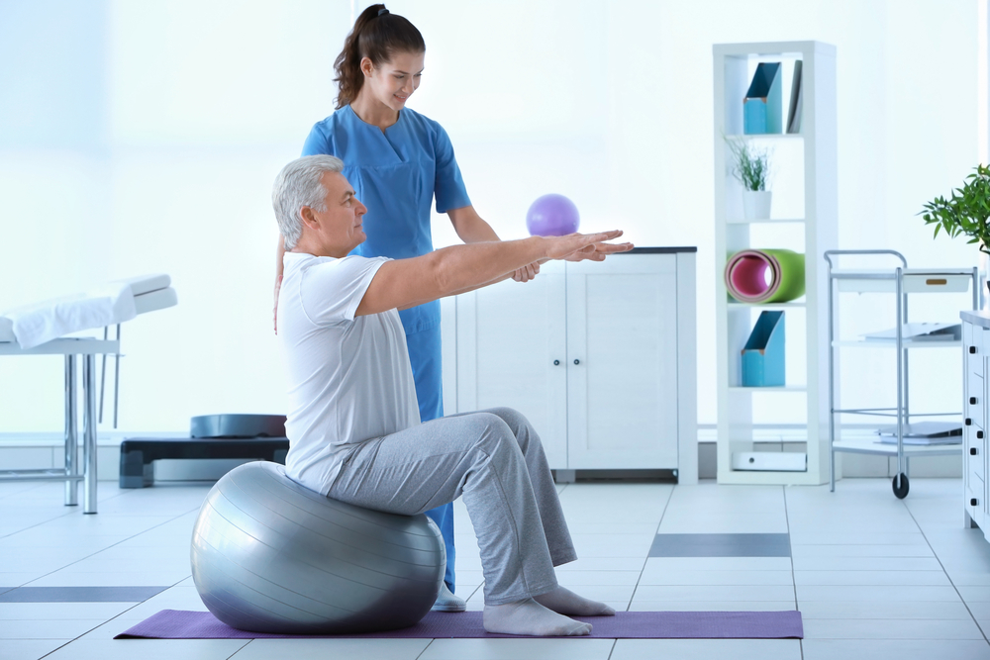

Physiotherapy department has a team of well qualified and experience physiotherapist Dr V.P Singh BPT MPT who provides quality care treatment. Every patient is given personalized treatment in comfortable environment.

Physiotherapy department is equipped with all modern equipment for providing electro therapy which includes laser, combination therapy, IFT, TENS, short wave diathermy. The department is constantly upgrade their knowledge to provide at most quality care and introduce new techniques for treatment.

* **Dentistry & maxillofacial**

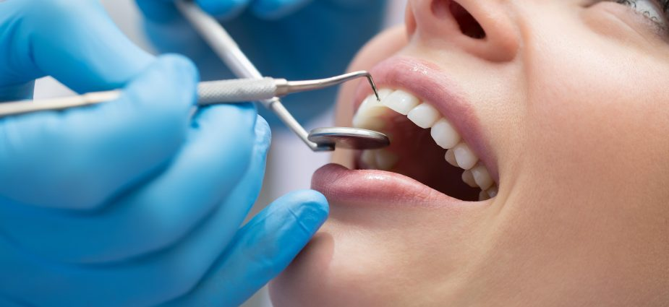

Our experienced and expert dental surgeons use the most up-to-date technology and high tech equipment to deliver the latest dental care treatment. This helps patients attain healthy improved quality of life.

We render facilities for all routines and specialized dental procedures while ensuring quality and excellent patient services in a caring and comfortable environment

The department specialized in orthodontics, oral medicine, prosthodontics, implantology, endodontic, oral surgery, periodontics, and prosthodontics. The dental emergencies like oral infection, visible swelling or trauma require immediate attention and must be treated on a priority basis.

* **Covered are under project**

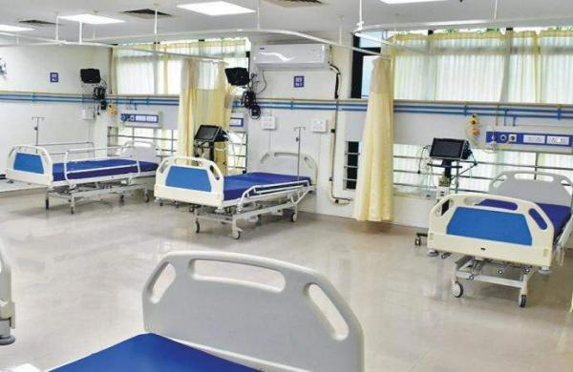

**google map of building location**

[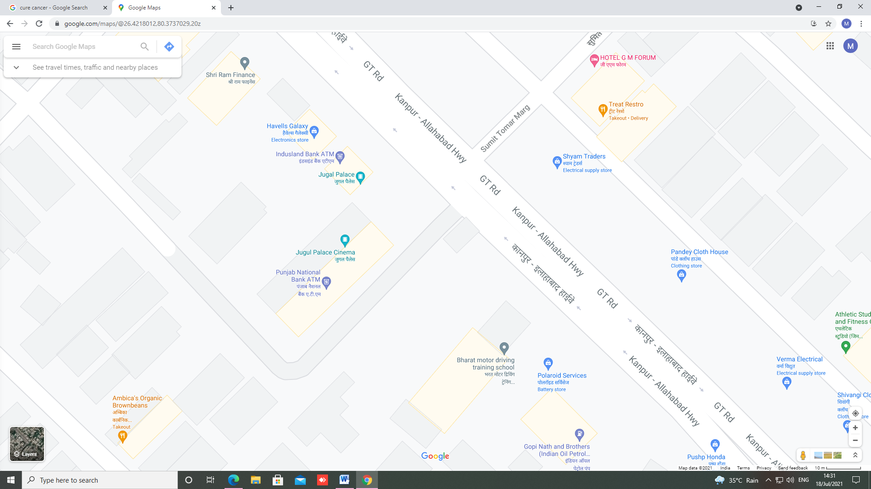](https://goo.gl/maps/UG6pw8rCLJ4RSPAm7)

Facilities

1. **Modular/Major Operation theater**

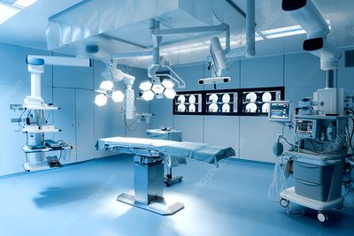

1. **Minor Operation theater**

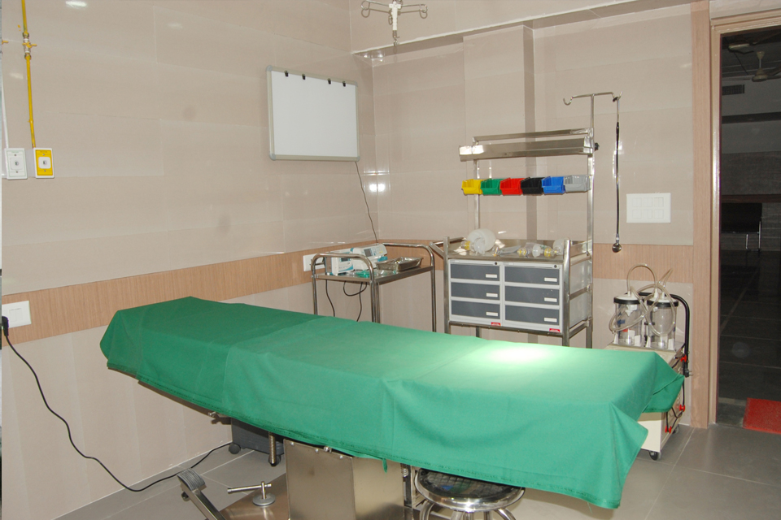

1. **Modern labour room**

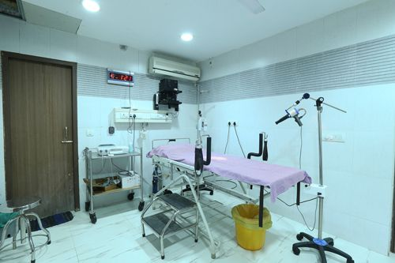

1. **Adult Intensive Care Unit**

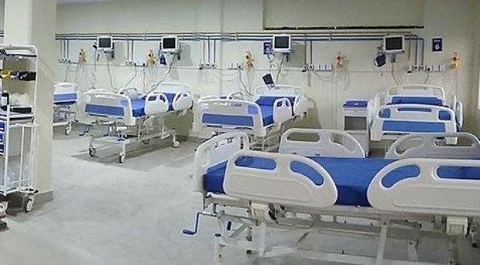

1. **Neonatal Intensive Care Unit**

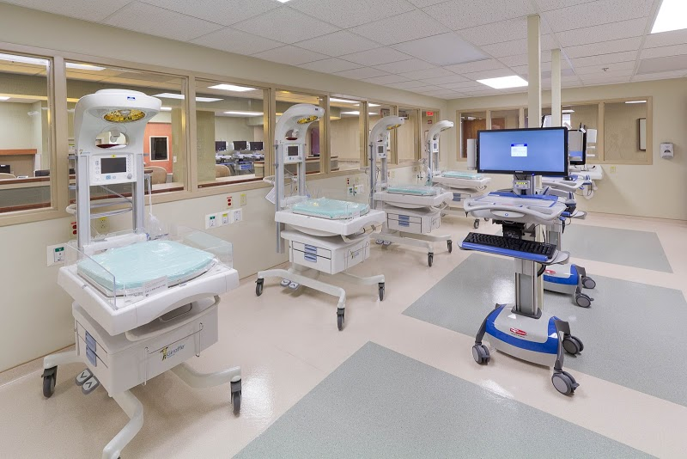

1. **Emergency / Causality Department**

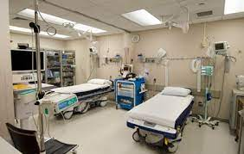

1. **In Patient Department**

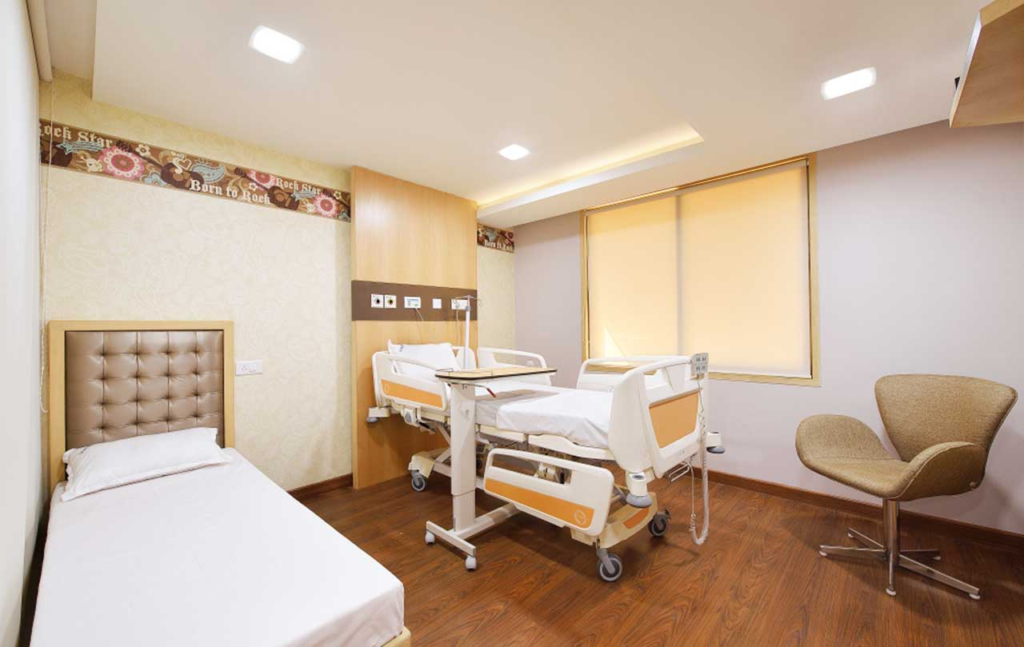

1. **Ambulance Services**

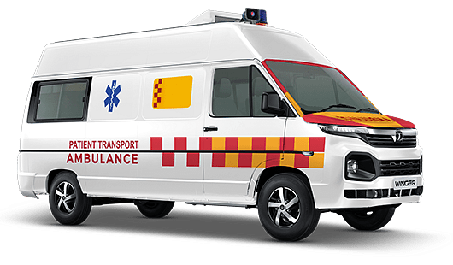

**Proposed Future Plan for Expansion of Specialty**

1. **Cath LaB**

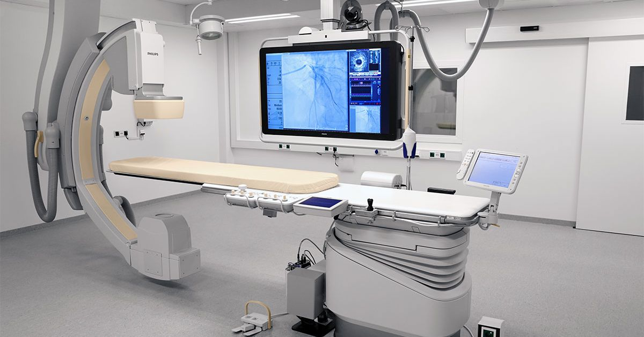

1. **Blood Bank**

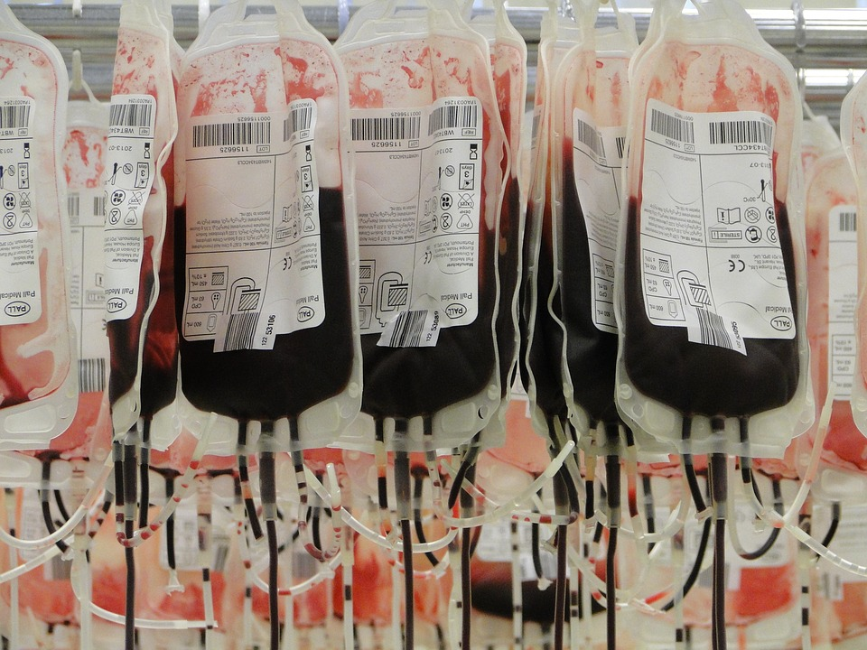

1. **MRI Machine (1.5 Tesla)**

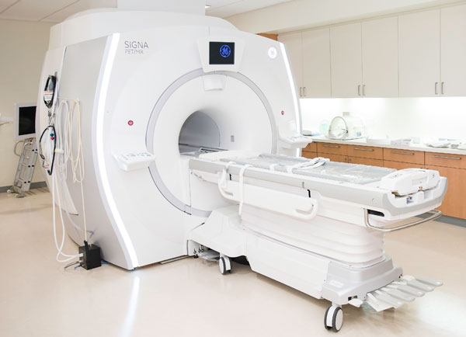

**Radiotherapy unit**